GitLab CLI

What is GitLab CLI
# Source: AI Source: Provided by: [Data Path: Persons Table -> ID Column: 1, Name_En Column: Motasem Essam] -> From: [ChatGPT] on [3/6/2026]
GitLab CLI (officially called glab) is a command-line tool that lets you interact with GitLab directly from your terminal instead of using the web interface.
Its main command is:
glab

What You Can Do With GitLab CLI
# Source: AI Source: Provided by: [Data Path: Persons Table -> ID Column: 1, Name_En Column: Motasem Essam] -> From: [ChatGPT] on [3/6/2026]
🔹 Manage Repositories
- Create new projects
- Clone repositories
- Fork repositories
- View repository info
Example:
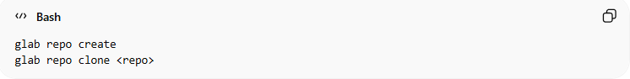
glab repo create
glab repo clone <repo>

🔹 Work With Merge Requests
# Source: AI Source: Provided by: [Data Path: Persons Table -> ID Column: 1, Name_En Column: Motasem Essam] -> From: [ChatGPT] on [3/6/2026]
- Create merge requests (MRs)
- Review MRs
- Merge MRs
- Check MR status
Example:
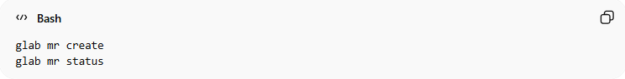
glab mr create
glab mr status

🔹 Handle Issues
# Source: AI Source: Provided by: [Data Path: Persons Table -> ID Column: 1, Name_En Column: Motasem Essam] -> From: [ChatGPT] on [3/6/2026]
- Create issues
- View issues
- Comment on issues
- Close issues
Example:
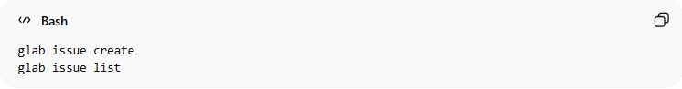
glab issue create
glab issue list

🔹 Manage Pipelines and CI/CD
# Source: AI Source: Provided by: [Data Path: Persons Table -> ID Column: 1, Name_En Column: Motasem Essam] -> From: [ChatGPT] on [3/6/2026]
Interact with GitLab CI/CD pipelines and jobs:
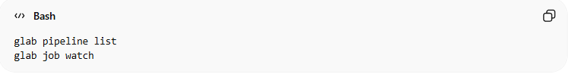
glab pipeline list
glab job watch

🔹 Authentication
# Source: AI Source: Provided by: [Data Path: Persons Table -> ID Column: 1, Name_En Column: Motasem Essam] -> From: [ChatGPT] on [3/6/2026]
Log in to your GitLab account securely:
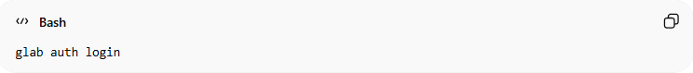
glab auth login

🔹 Refresh GitLab CLI Authentication
# Source: AI Source: Provided by: [Data Path: Persons Table -> ID Column: 1, Name_En Column: Motasem Essam] -> From: [ChatGPT] on [3/6/2026]
Sometimes your GitLab CLI (glab) authentication token may expire or need to be refreshed. You can update or re-authenticate from the terminal.

1️⃣ Check Current Authentication Status
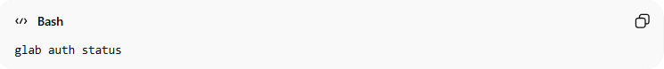
glab auth status
- Shows whether you are currently logged in.
- Displays your GitLab username and authentication method (OAuth or Personal Access Token).

2️⃣ Log Out (Optional)
If you want to start fresh:
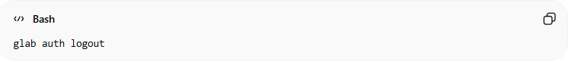
glab auth logout
- Logs you out of GitLab CLI.
- You can choose to log out of all accounts or a specific account if multiple are used.

3️⃣ Log In / Refresh Authentication
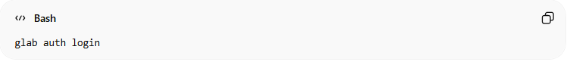
glab auth login
- Follow the interactive prompts:
  - Choose GitLab.com or a self-hosted GitLab instance.
  - Select HTTPS or SSH for Git operations.
  - Choose authentication method: Web browser or Personal Access Token (PAT).
  - Complete authentication to refresh your token.

4️⃣ Verify New Authentication
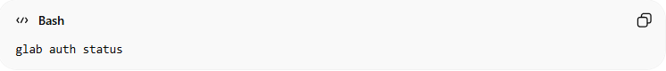
glab auth status
- Confirms that your CLI is authenticated with a valid token.
- You can now run glab commands (projects, issues, merge requests, pipelines) without authentication errors.

💡 Notes
- Web browser login → simple for interactive use.
- Personal Access Token (PAT) → best for automation or scripts.
- Refreshing your token ensures seamless interaction with GitLab from the terminal.

Why Use GitLab CLI?
# Source: AI Source: Provided by: [Data Path: Persons Table -> ID Column: 1, Name_En Column: Motasem Essam] -> From: [ChatGPT] on [3/6/2026]
- ⚡ Faster than using the browser
- 🧠 Ideal for developers who prefer working in the terminal
- 🔄 Simplifies automation and scripting
- 🔗 Works alongside Git commands

Simple Example Workflow
# Source: AI Source: Provided by: [Data Path: Persons Table -> ID Column: 1, Name_En Column: Motasem Essam] -> From: [ChatGPT] on [3/6/2026]
Instead of:
- Push code
- Open GitLab in browser
- Create merge request manually
You can:
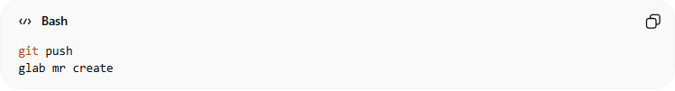
git push
glab mr create

GitHub CLI vs GitLab CLI commands
# Source: AI Source: Provided by: [Data Path: Persons Table -> ID Column: 1, Name_En Column: Motasem Essam] -> From: [ChatGPT] on [3/6/2026]
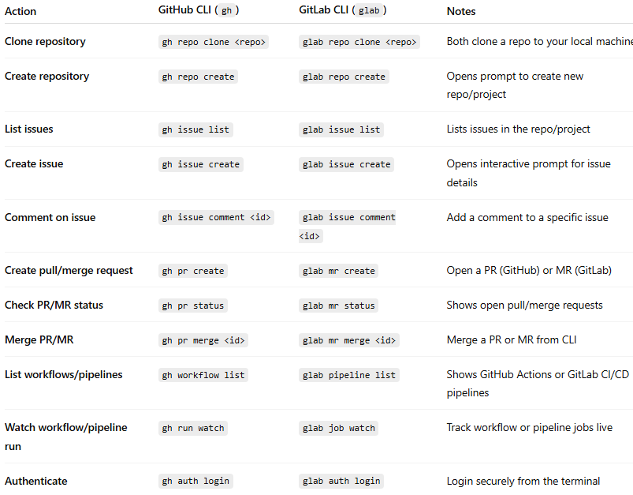
Action | GitHub CLI (gh) | GitLab CLI (glab) | Notes
Clone repository | gh repo clone <repo> | glab repo clone <repo> | Both clone a repo to your local machine
Create repository | gh repo create | glab repo create | Opens prompt to create new repo/project
List issues | gh issue list | glab issue list | Lists issues in the repo/project
Create issue | gh issue create | glab issue create | Opens interactive prompt for issue details
Comment on issue | gh issue comment <id> | glab issue comment <id> | Add a comment to a specific issue
Create pull/merge request | gh pr create | glab mr create | Open a PR (GitHub) or MR (GitLab)
Check PR/MR status | gh pr status | glab mr status | Shows open pull/merge requests
Merge PR/MR | gh pr merge <id> | glab mr merge <id> | Merge a PR or MR from CLI
List workflows/pipelines | gh workflow list | glab pipeline list | Shows GitHub Actions or GitLab CI/CD pipelines
Watch workflow/pipeline run | gh run watch | glab job watch | Track workflow or pipeline jobs live
Authenticate | gh auth login | glab auth login | Login securely from the terminal

Download GitLab CLI
# Source: ScreenShots Source: Provided by: [Persons Table -> ID Column: 1, Name_En Column: Motasem Essam] -> Tool: [Lightshot Program] -> From [Site: Google Search: All: GitLab CLI] on [3/6/2026]
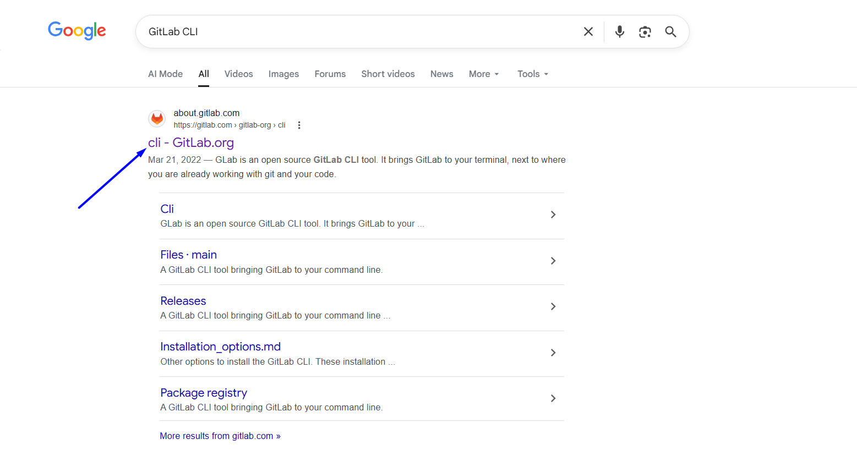
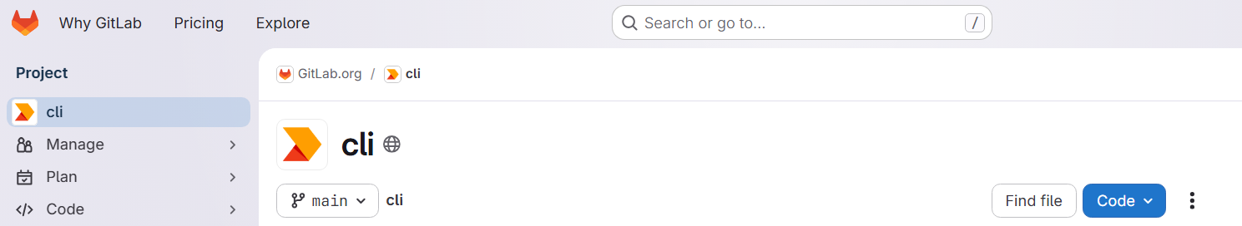
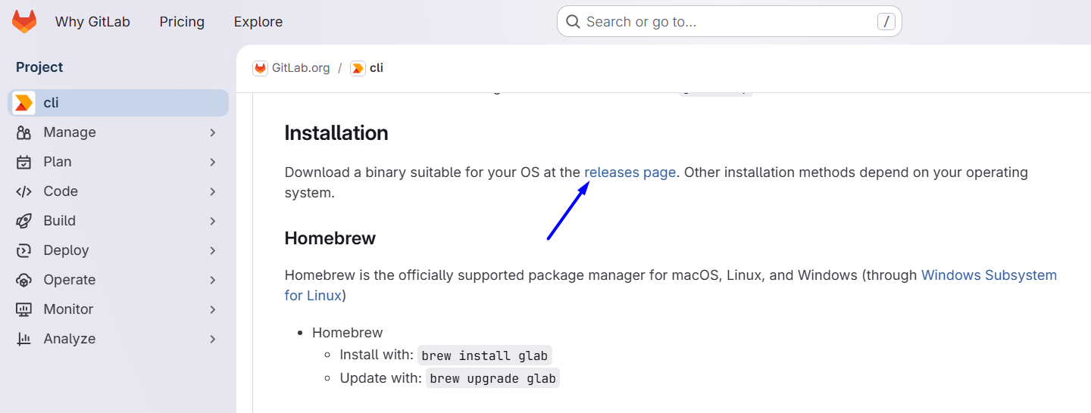

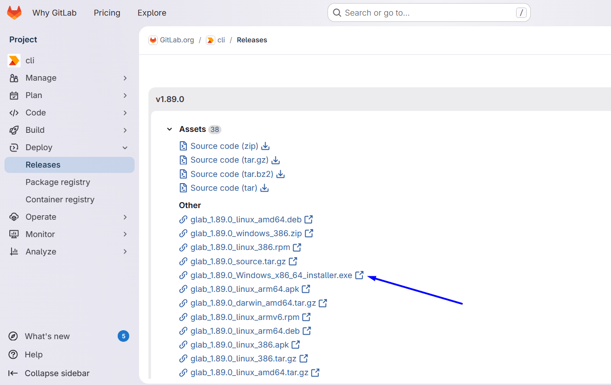
# Source: ScreenShots Source: Provided by: [Persons Table -> ID Column: 1, Name_En Column: Motasem Essam] -> Tool: [Lightshot Program] -> From [Operating System: Windows] on [3/6/2026]
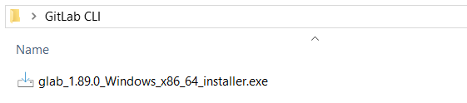

Install GitLab CLI
# Source: ScreenShots Source: Provided by: [Persons Table -> ID Column: 1, Name_En Column: Motasem Essam] -> Tool: [Lightshot Program] -> From [Operating System: Windows] on [3/6/2026]
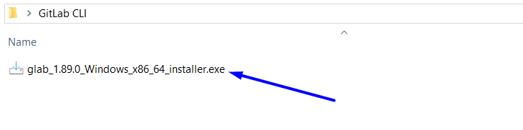
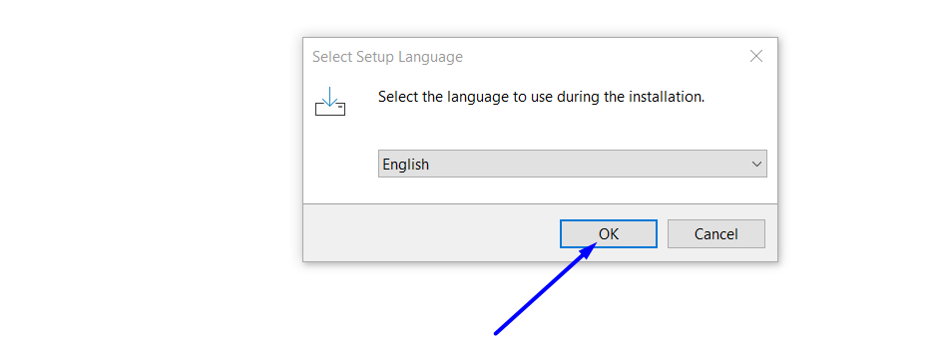
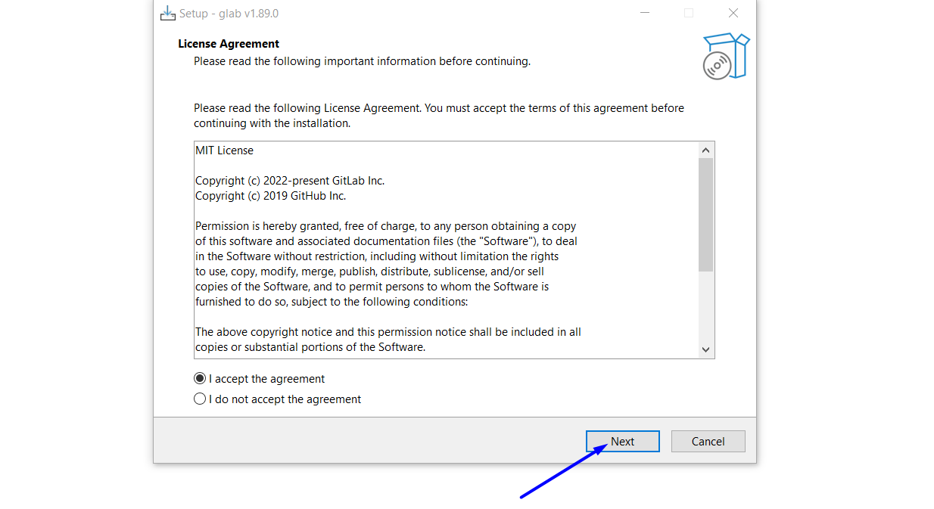
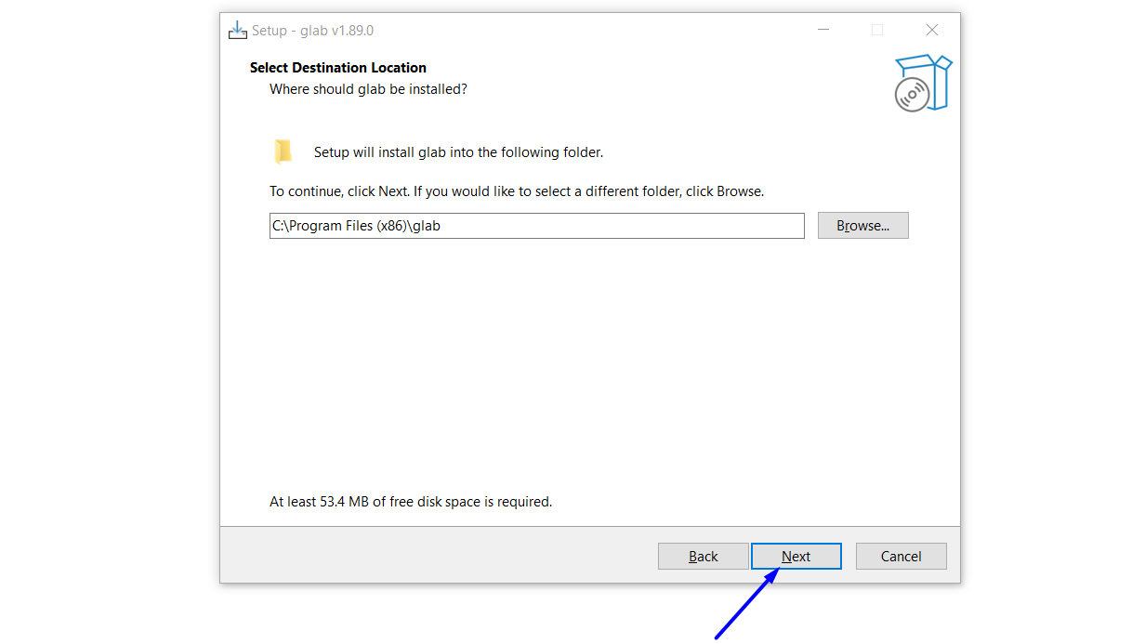
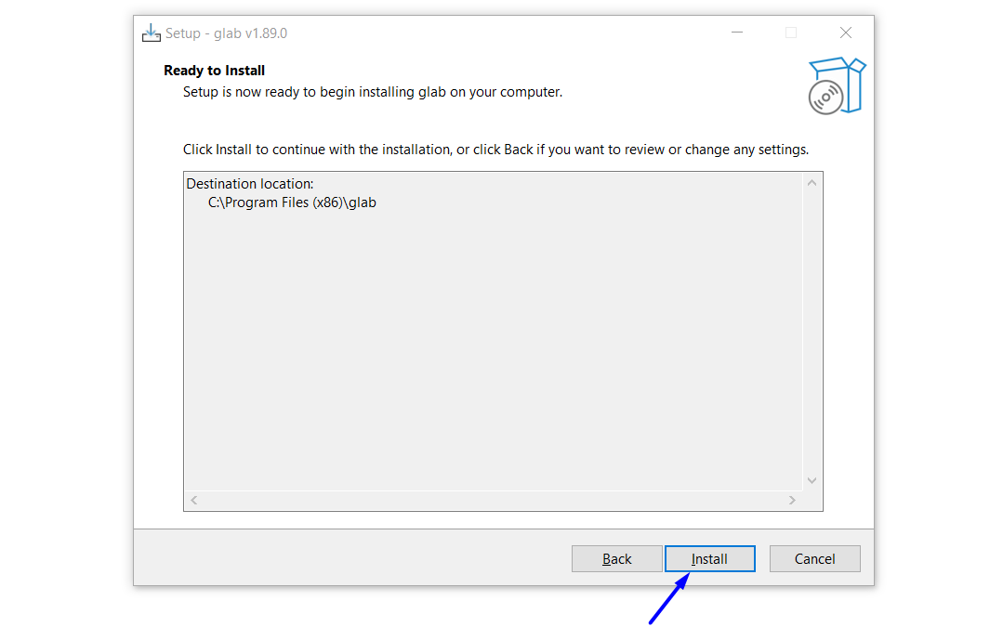

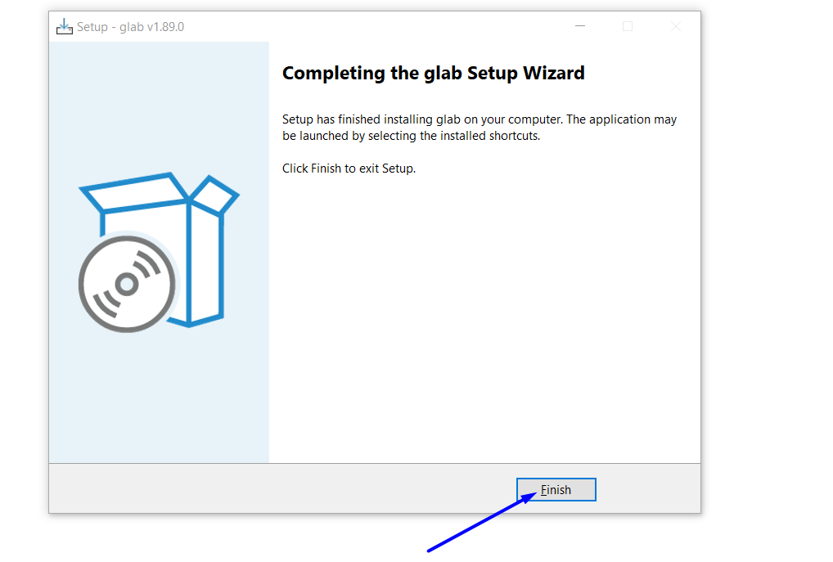

Add glab to the Windows PATH Environment Variable
# Source: ScreenShots Source: Provided by: [Persons Table -> ID Column: 1, Name_En Column: Motasem Essam] -> Tool: [Lightshot Program] -> From [Operating System: Windows] on [3/6/2026]
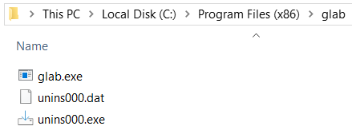
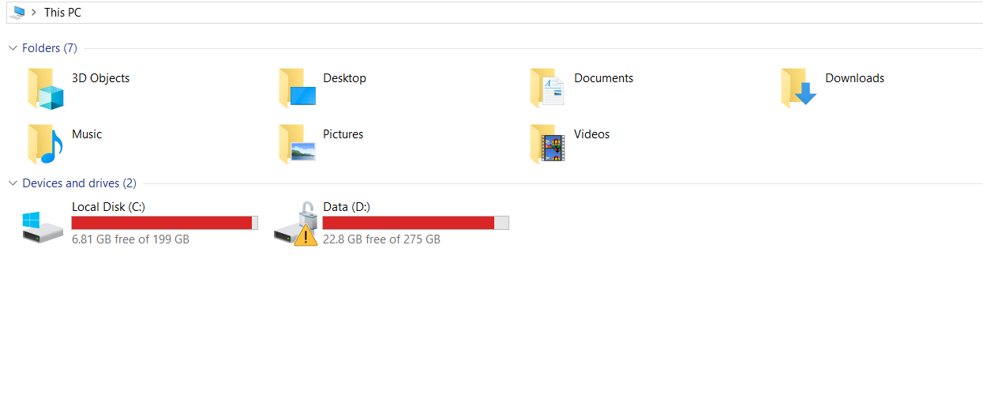
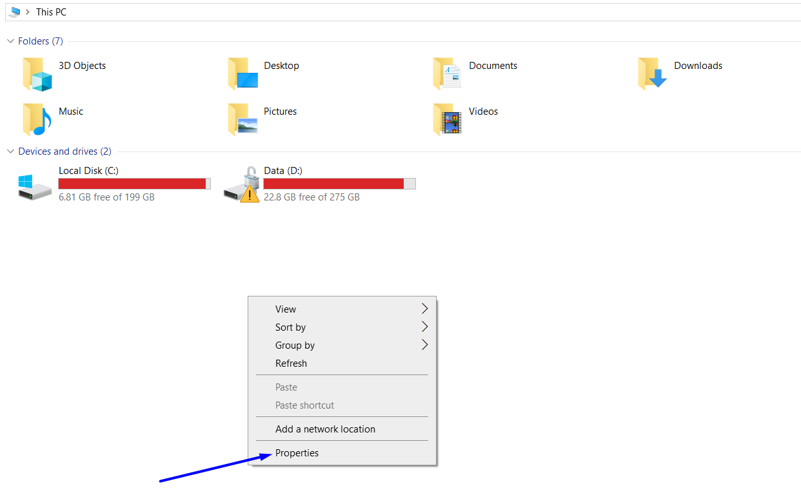
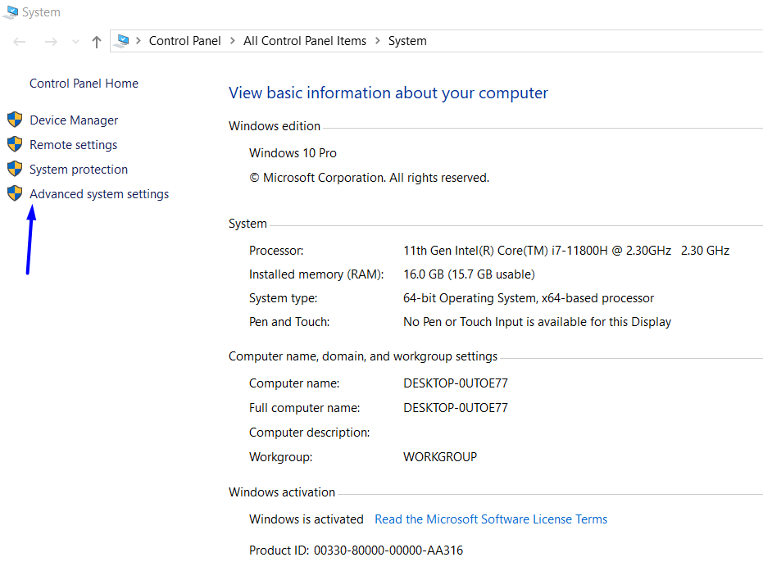
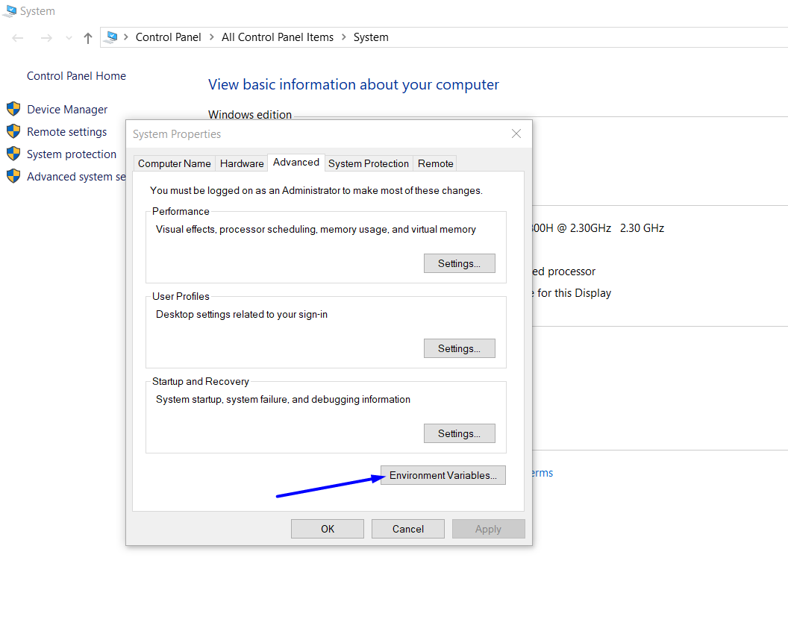
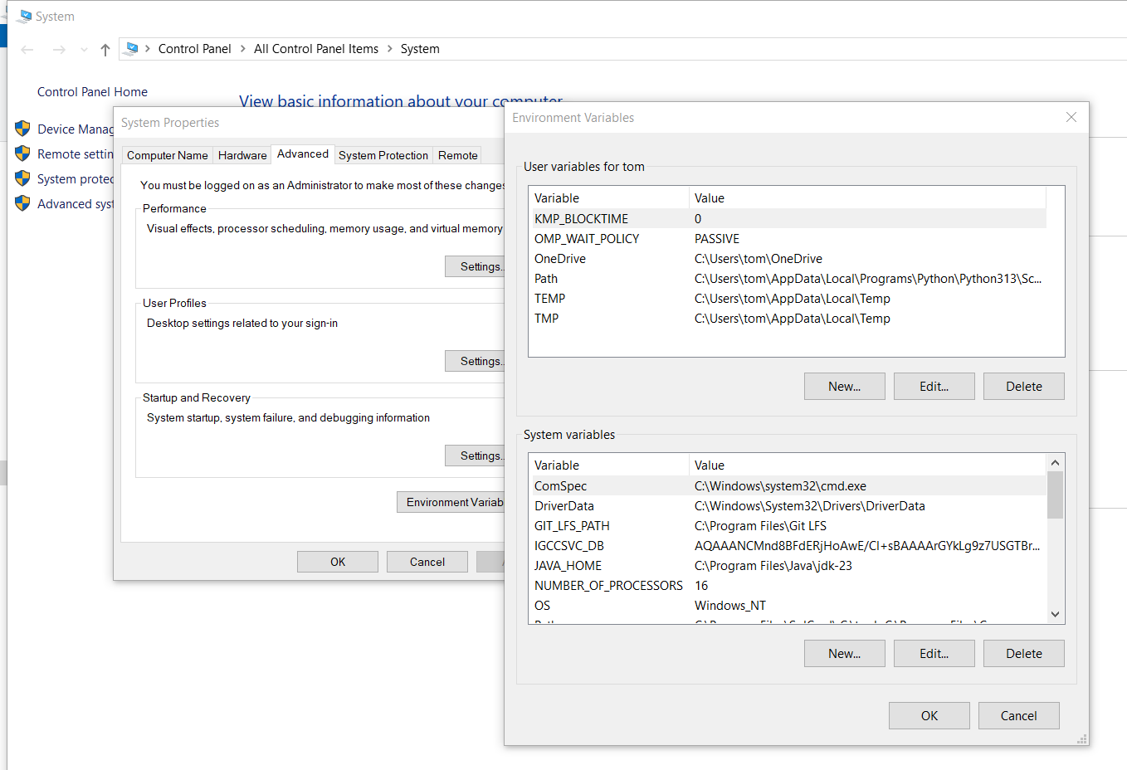
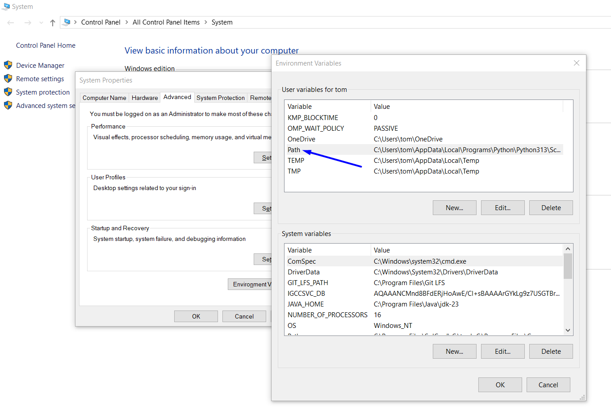
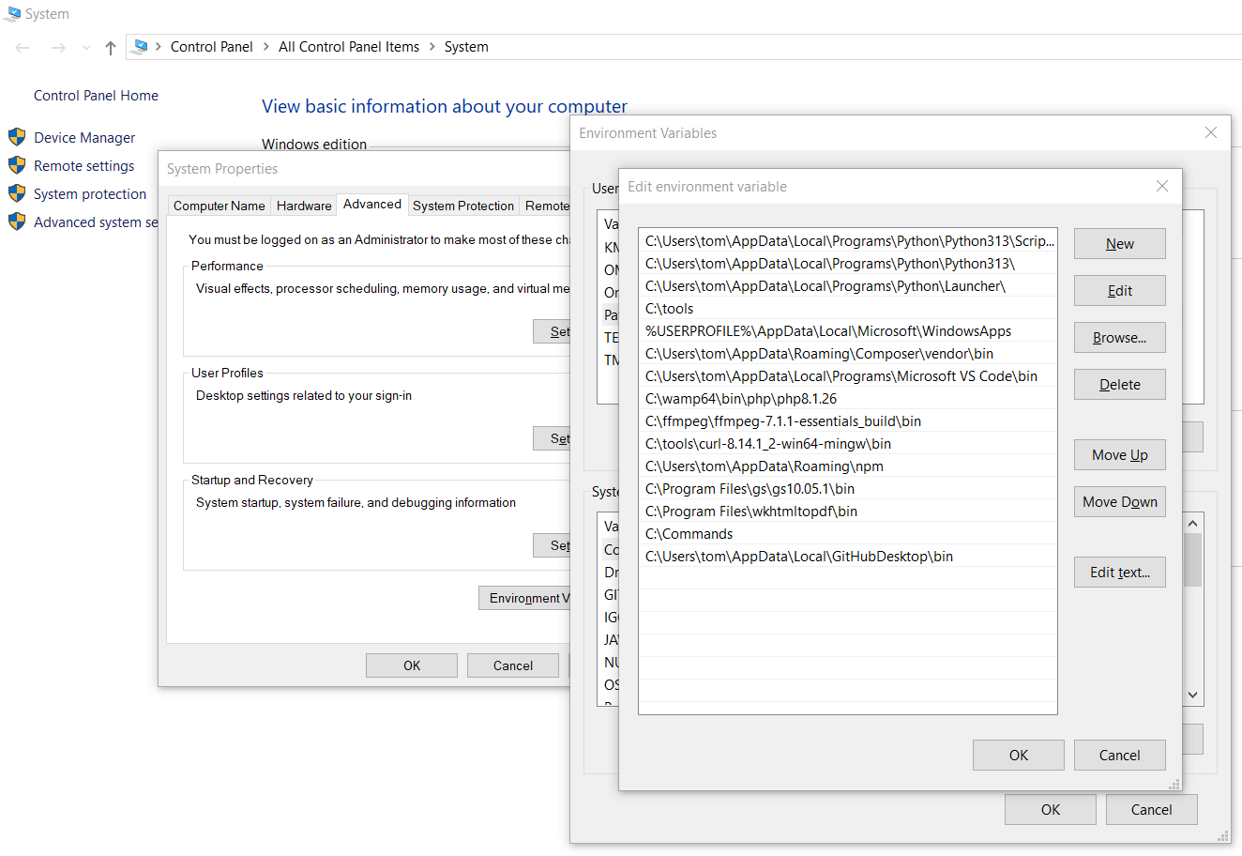
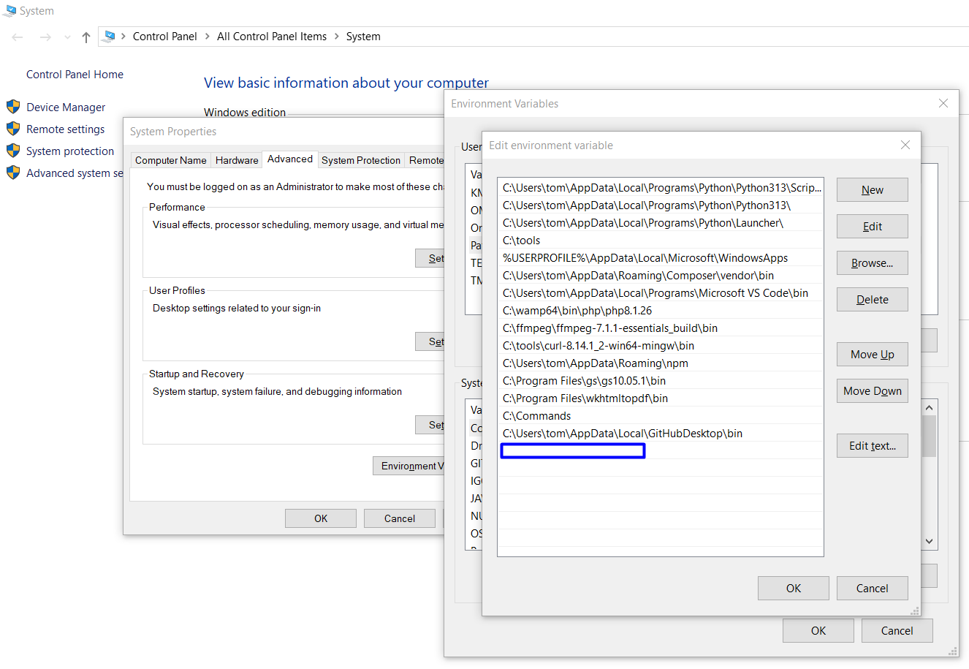
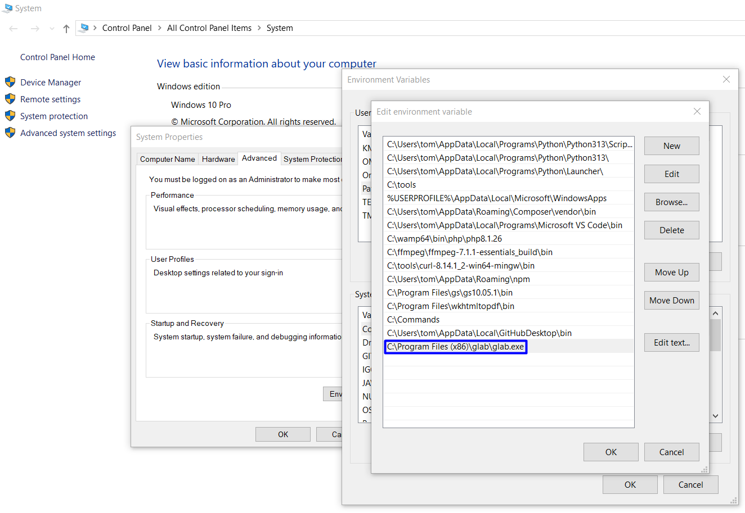

Run GitLab CLI
# Source: ScreenShots Source: Provided by: [Persons Table -> ID Column: 1, Name_En Column: Motasem Essam] -> Tool: [Lightshot Program] -> From [Operating System: Windows] on [3/6/2026]
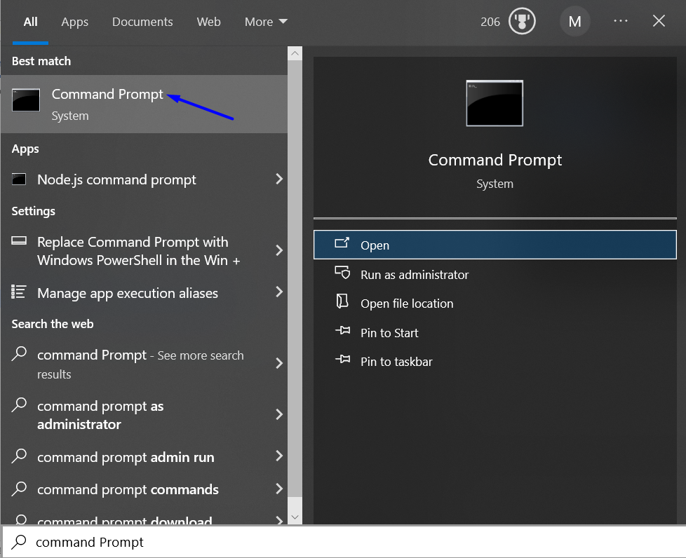
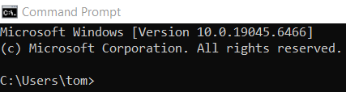
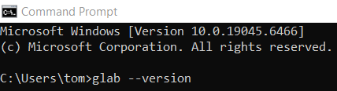
glab –version
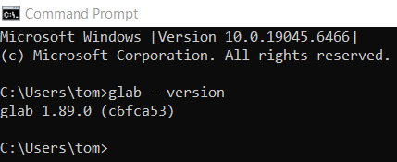

Log In
# Source: ScreenShots Source: Provided by: [Persons Table -> ID Column: 1, Name_En Column: Motasem Essam] -> Tool: [Lightshot Program] -> From [Operating System: Windows] on [3/6/2026]
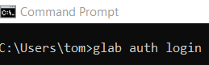
glab auth login
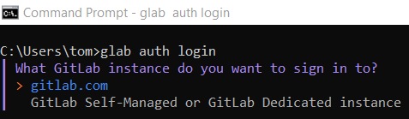
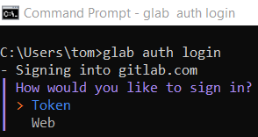
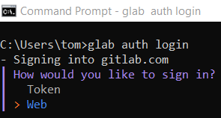
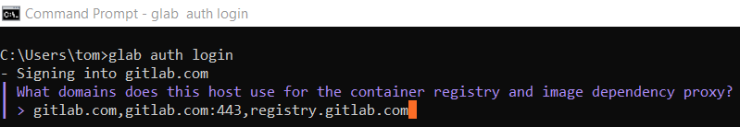
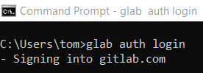

# Source: ScreenShots Source: Provided by: [Persons Table -> ID Column: 1, Name_En Column: Motasem Essam] -> Tool: [Lightshot Program] -> From [Site: https://gitlab.com/] on [3/6/2026]
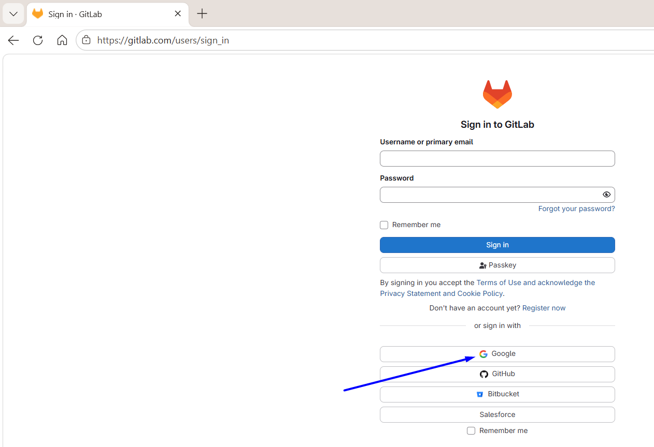
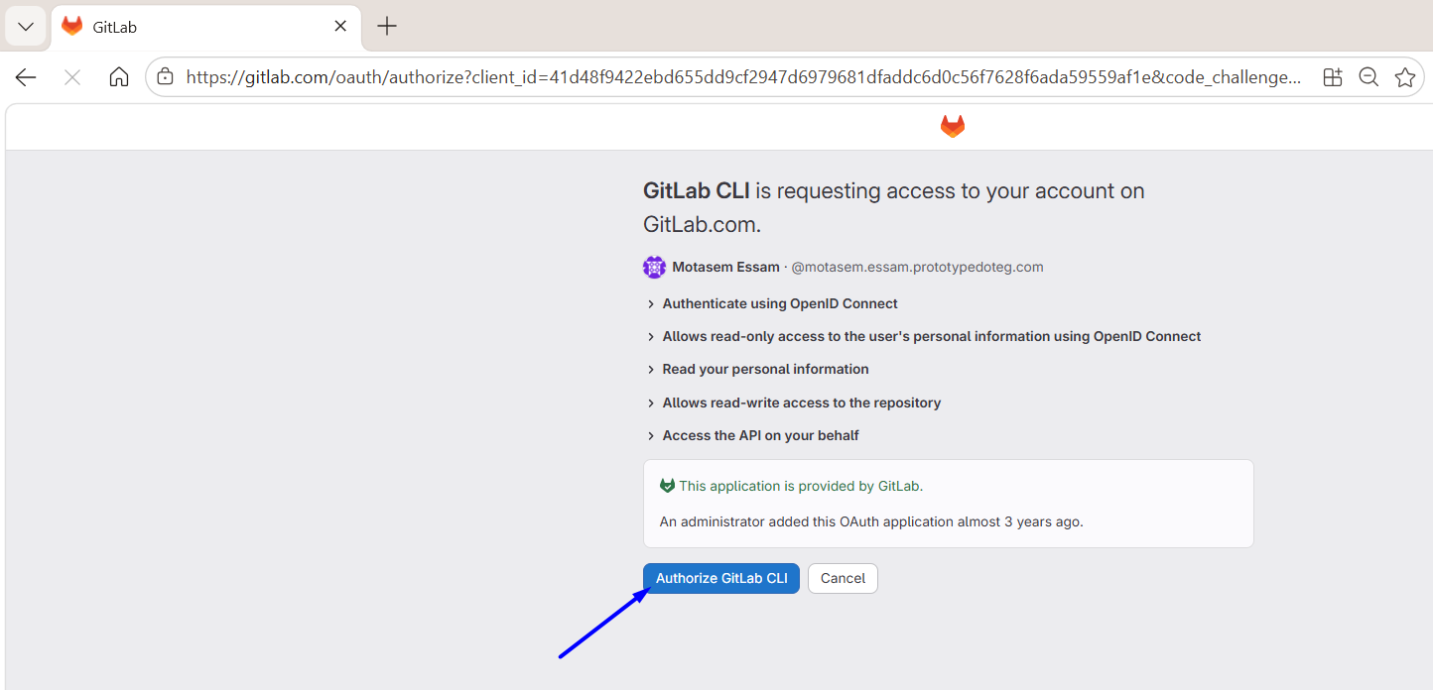
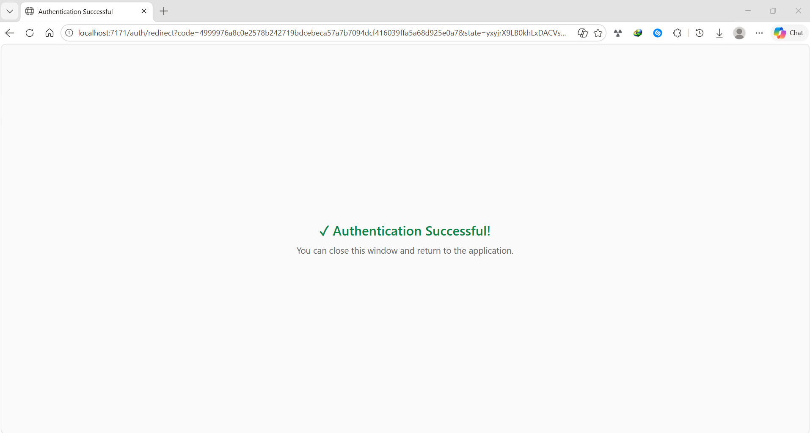
# Source: ScreenShots Source: Provided by: [Persons Table -> ID Column: 1, Name_En Column: Motasem Essam] -> Tool: [Lightshot Program] -> From [Operating System: Windows] on [3/6/2026]
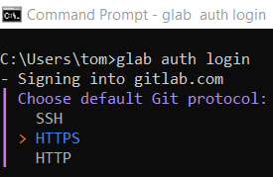
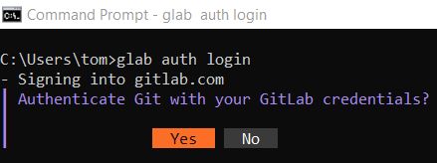
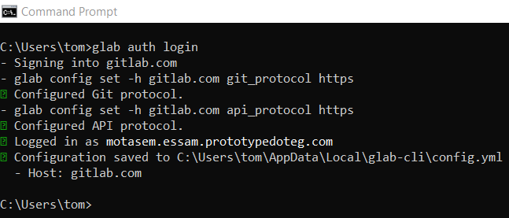

Viewing Your Repositories
# Source: ScreenShots Source: Provided by: [Persons Table -> ID Column: 1, Name_En Column: Motasem Essam] -> Tool: [Lightshot Program] -> From [Operating System: Windows] on [3/6/2026]
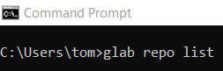
glab repo list
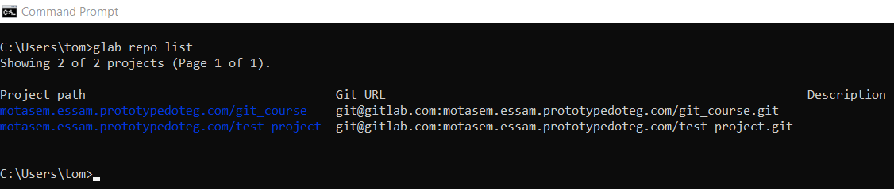

New repository
# Source: ScreenShots Source: Provided by: [Persons Table -> ID Column: 1, Name_En Column: Motasem Essam] -> Tool: [Lightshot Program] -> From [Operating System: Windows] on [3/6/2026]
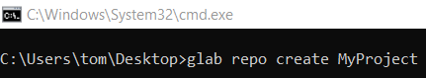
glab repo create MyProject
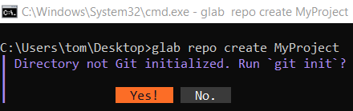
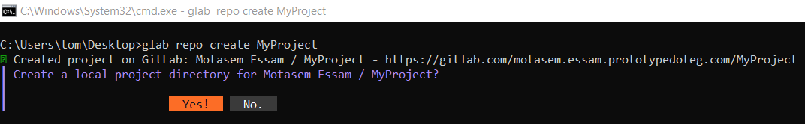
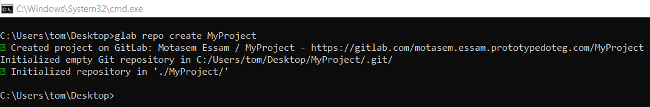
# Source: ScreenShots Source: Provided by: [Persons Table -> ID Column: 1, Name_En Column: Motasem Essam] -> Tool: [Lightshot Program] -> From [Site: https://gitlab.com/] on [3/6/2026]
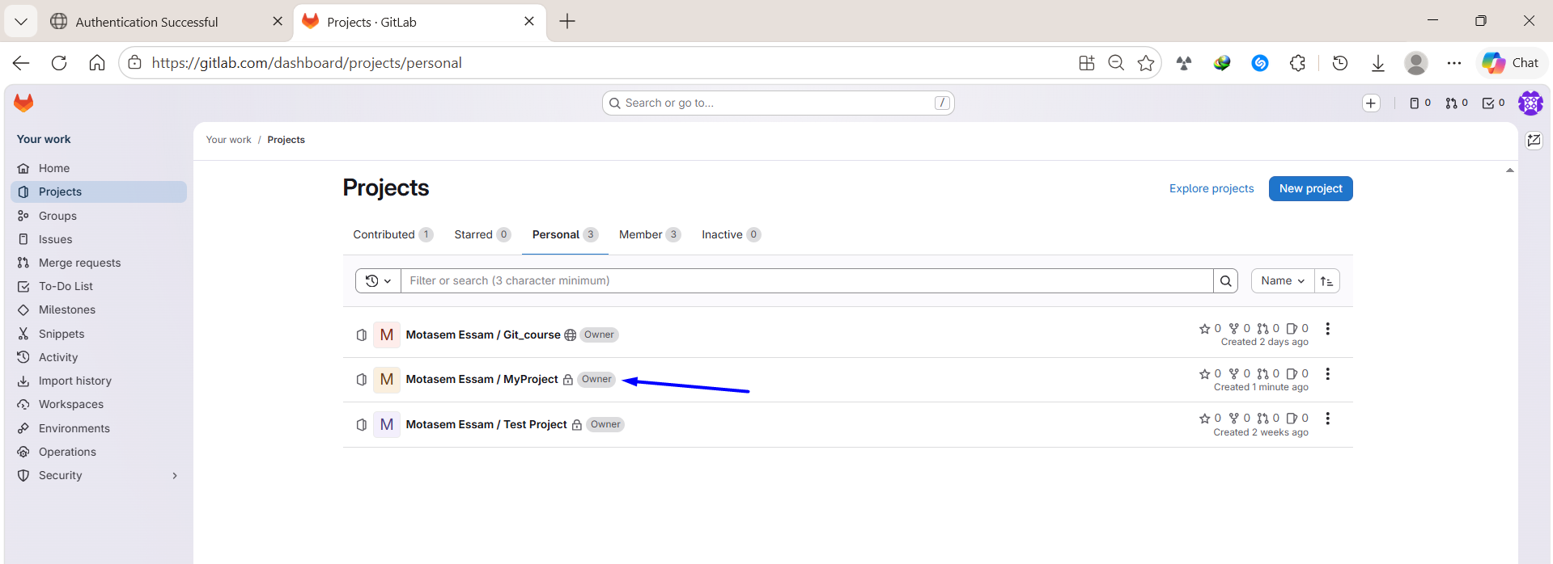

Check if the repo exists (using CLI)
# Source: ScreenShots Source: Provided by: [Persons Table -> ID Column: 1, Name_En Column: Motasem Essam] -> Tool: [Lightshot Program] -> From [Operating System: Windows] on [3/6/2026]
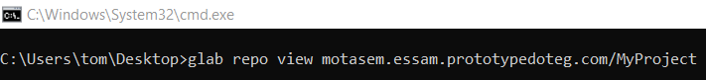
glab repo view motasem.essam.prototypedoteg.com/MyProject
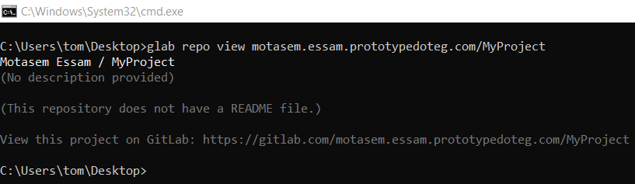

Delete Repository Using GitLab CLI
# Source: ScreenShots Source: Provided by: [Persons Table -> ID Column: 1, Name_En Column: Motasem Essam] -> Tool: [Lightshot Program] -> From [Operating System: Windows] on [3/6/2026]
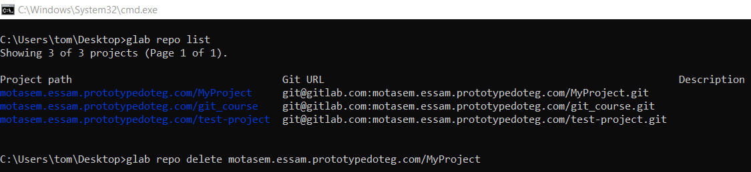
glab repo delete motasem.essam.prototypedoteg.com/MyProject
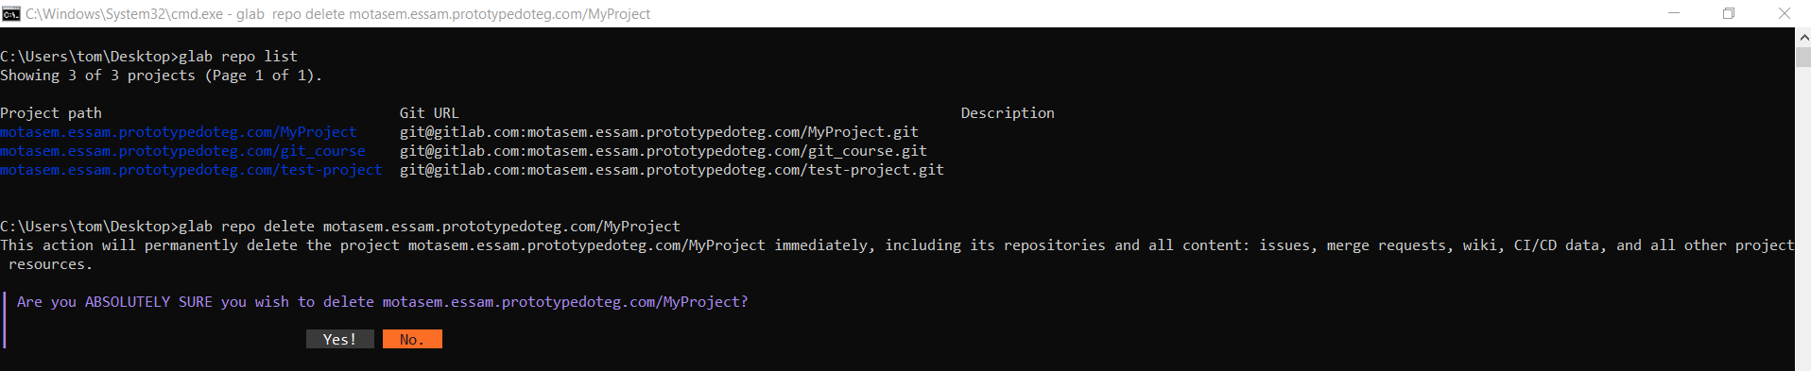
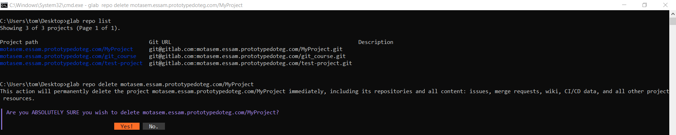
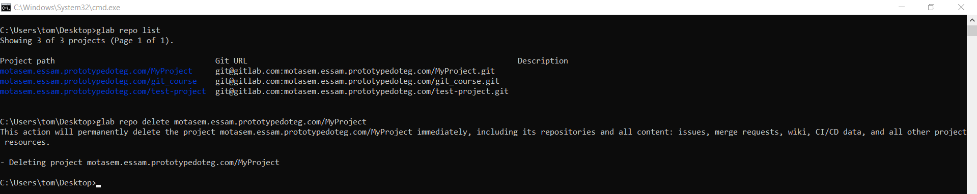

Clone Repository
# Source: ScreenShots Source: Provided by: [Persons Table -> ID Column: 1, Name_En Column: Motasem Essam] -> Tool: [Lightshot Program] -> From [Site: https://gitlab.com/] on [3/6/2026]
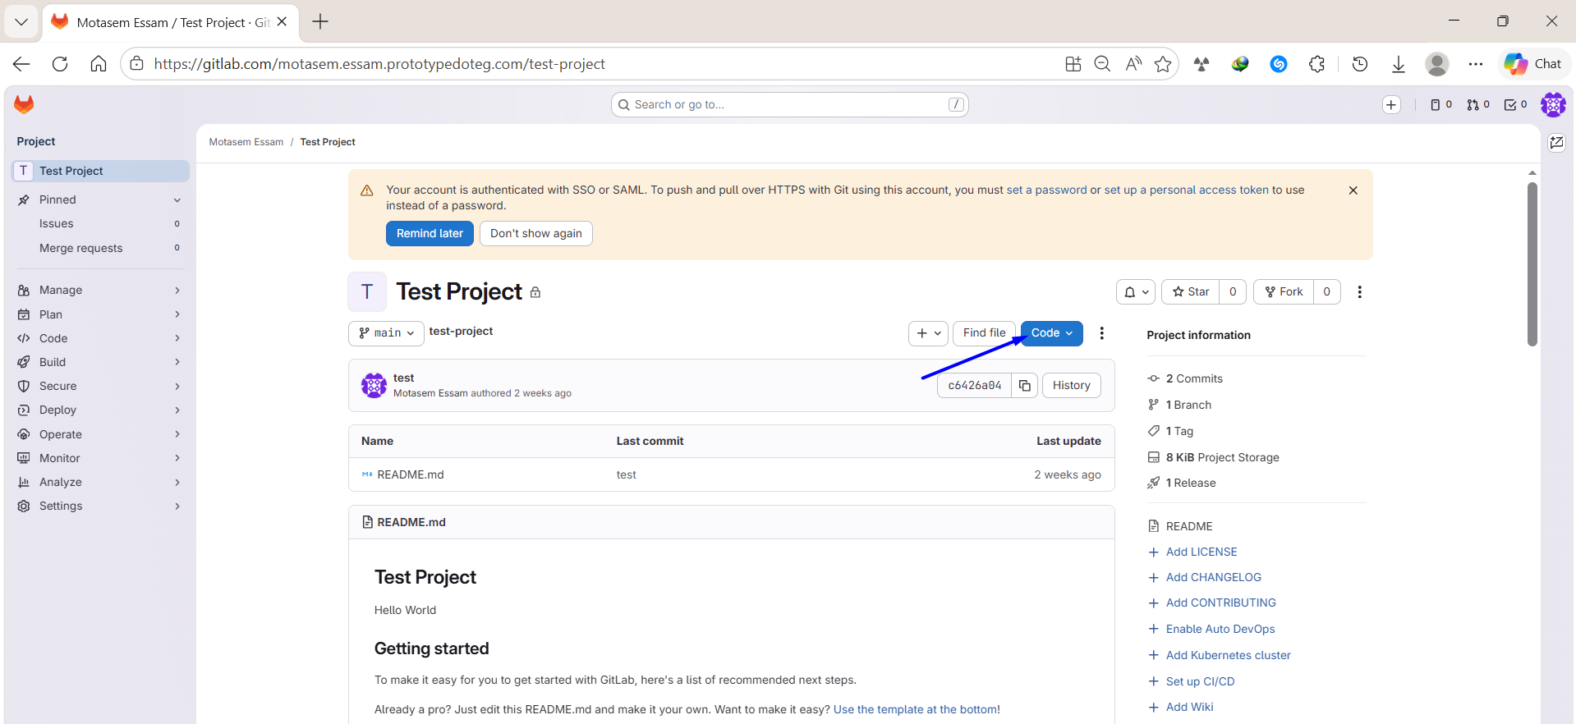
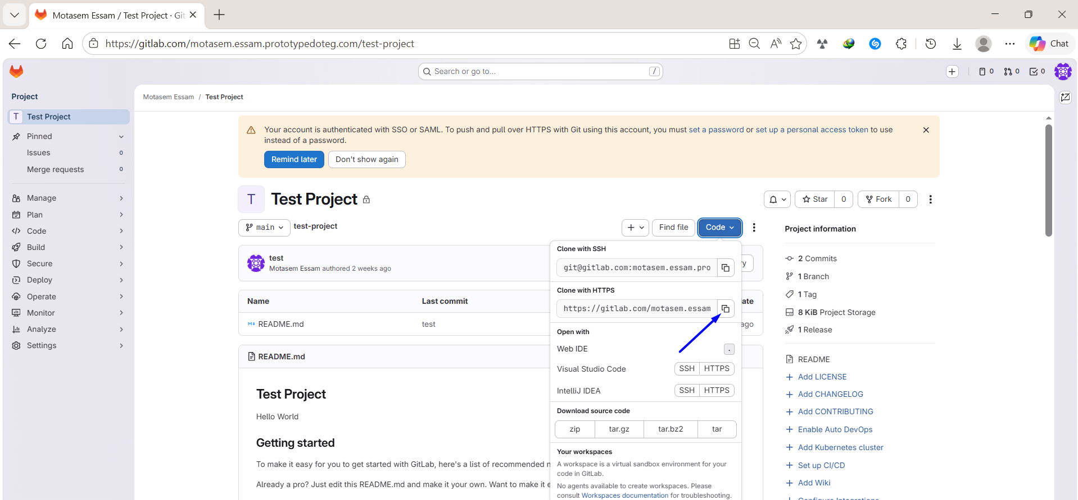
# Source: ScreenShots Source: Provided by: [Persons Table -> ID Column: 1, Name_En Column: Motasem Essam] -> Tool: [Lightshot Program] -> From [Operating System: Windows] on [3/6/2026]
glab repo clone https://gitlab.com/motasem.essam.prototypedoteg.com/test-project.git
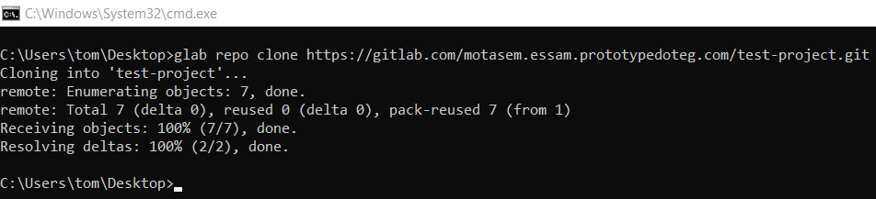

GitLab CLI Stages

1️⃣ (First Time Only) – Login with GitLab CLI
# Source: AI Source: Provided by: [Data Path: Persons Table -> ID Column: 1, Name_En Column: Motasem Essam] -> From: [ChatGPT] on [3/6/2026]
Authenticate your machine with GitLab:
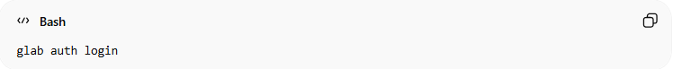
glab auth login
Follow the prompts:
- Choose GitLab.com (or your self-hosted instance)
- Choose HTTPS or SSH
- Authorize in browser or provide a personal access token
✅ Now your Git is connected to GitLab securely.

2️⃣ Add Changes
# Source: AI Source: Provided by: [Data Path: Persons Table -> ID Column: 1, Name_En Column: Motasem Essam] -> From: [ChatGPT] on [3/6/2026]
Stage files for commit:
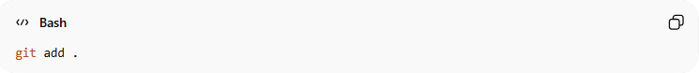
git add .
Or stage specific file(s):
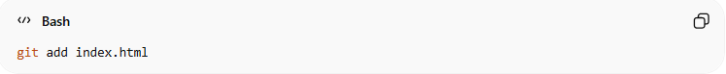
git add index.html

3️⃣ Commit Changes
# Source: AI Source: Provided by: [Data Path: Persons Table -> ID Column: 1, Name_En Column: Motasem Essam] -> From: [ChatGPT] on [3/6/2026]
Commit the staged changes with a message:
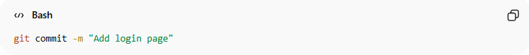
git commit -m "Add login page"

4️⃣ Push to GitLab
# Source: AI Source: Provided by: [Data Path: Persons Table -> ID Column: 1, Name_En Column: Motasem Essam] -> From: [ChatGPT] on [3/6/2026]
Push your branch to GitLab:
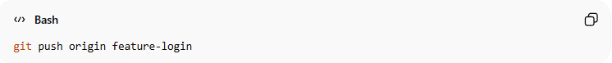
git push origin feature-login
If this is the first push for a new branch:
git push -u origin feature-login

5️⃣ Create a Merge Request Using GitLab CLI
# Source: AI Source: Provided by: [Data Path: Persons Table -> ID Column: 1, Name_En Column: Motasem Essam] -> From: [ChatGPT] on [3/6/2026]
After pushing your branch, create an MR directly from terminal:
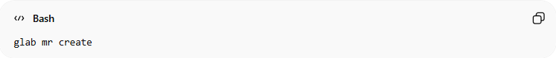
glab mr create
It will ask for:
- Target branch (usually main or master)
- Title
- Description
Or create it directly:
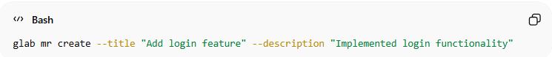
glab mr create --title "Add login feature" --description "Implemented login functionality"
Breakdown:
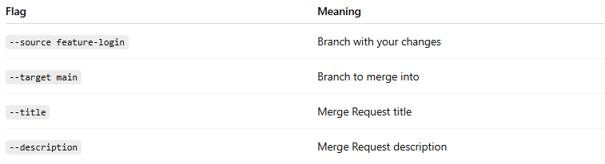
Flag | Meaning
--source feature-login | Branch with your changes
--target main | Branch to merge into
--title | Merge Request title
--description | Merge Request description

🔁 Full Workflow Example
# Source: AI Source: Provided by: [Data Path: Persons Table -> ID Column: 1, Name_En Column: Motasem Essam] -> From: [ChatGPT] on [3/6/2026]
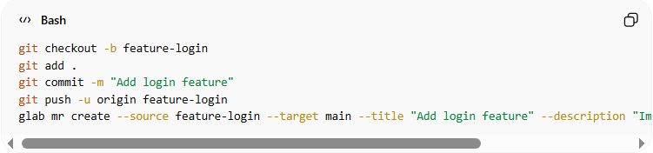
git checkout -b feature-login
git add .
git commit -m "Add login feature"
git push -u origin feature-login
glab mr create --source feature-login --target main --title "Add login feature" --description "Implemented login functionality"

🧠 What glab Actually Does vs Git
# Source: AI Source: Provided by: [Data Path: Persons Table -> ID Column: 1, Name_En Column: Motasem Essam] -> From: [ChatGPT] on [3/6/2026]
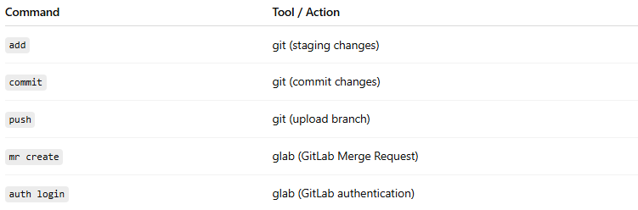
Command | Tool / Action
add | git (staging changes)
commit | git (commit changes)
push | git (upload branch)
mr create | glab (GitLab Merge Request)
auth login | glab (GitLab authentication)
Remember:
- git = version control
- glab = GitLab platform interaction (MRs, pipelines, repos)

Example

1️⃣ (First Time Only) – Login with GitLab CLI
# Source: ScreenShots Source: Provided by: [Persons Table -> ID Column: 1, Name_En Column: Motasem Essam] -> Tool: [Lightshot Program] -> From [Operating System: Windows] on [3/6/2026]

glab auth login





# Source: ScreenShots Source: Provided by: [Persons Table -> ID Column: 1, Name_En Column: Motasem Essam] -> Tool: [Lightshot Program] -> From [Site: https://gitlab.com/] on [3/6/2026]



# Source: ScreenShots Source: Provided by: [Persons Table -> ID Column: 1, Name_En Column: Motasem Essam] -> Tool: [Lightshot Program] -> From [Operating System: Windows] on [3/6/2026]




2️⃣ Add Changes
# Source: ScreenShots Source: Provided by: [Persons Table -> ID Column: 1, Name_En Column: Motasem Essam] -> Tool: [Lightshot Program] -> From [Operating System: Windows] on [3/6/2026]
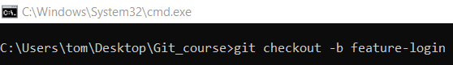
git checkout -b feature-login
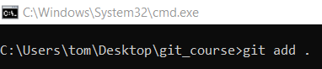
git add .

3️⃣ Commit Changes
# Source: ScreenShots Source: Provided by: [Persons Table -> ID Column: 1, Name_En Column: Motasem Essam] -> Tool: [Lightshot Program] -> From [Operating System: Windows] on [3/6/2026]
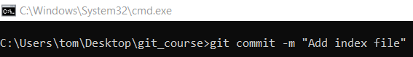
git commit -m "Add index file"
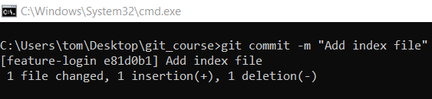

4️⃣ Push to GitHub
# Source: ScreenShots Source: Provided by: [Persons Table -> ID Column: 1, Name_En Column: Motasem Essam] -> Tool: [Lightshot Program] -> From [Operating System: Windows] on [3/6/2026]
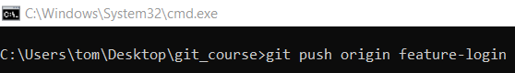
git push origin feature-login
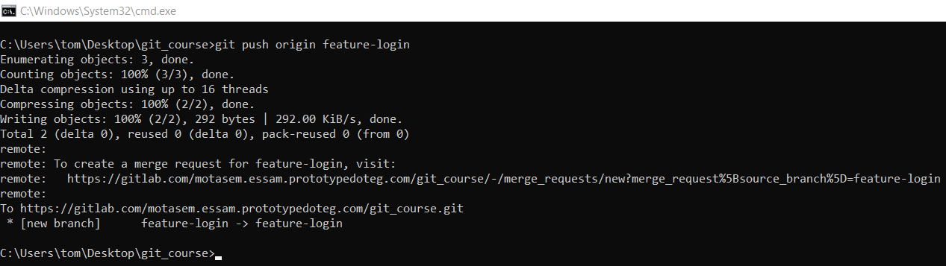

5️⃣ Create a Merge Request Using GitLab CLI
# Source: ScreenShots Source: Provided by: [Persons Table -> ID Column: 1, Name_En Column: Motasem Essam] -> Tool: [Lightshot Program] -> From [Operating System: Windows] on [3/6/2026]
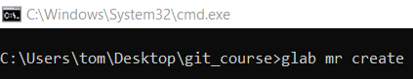
glab mr create

